**UNIVERSAL**

**REPORTER**

**Full description:** An app that allows users anywhere in the world to report any relevant, important, or interesting event, situation, or activity happening around them in real-time.

All the users will get the real-time notifications of all the reported events based on their filters and location previously adjusted in their devices.

Submissions of events can attached a pic and a quick descriptive note.

Users attending to the reported event will have the chance to quickly review event accuracy to avoid false reports and rank trusted users.

**Purpose of Idea:** To be connected and aware of everything that is happening around you.

**Features List:**

Submission of events classified by criteria:

Severity (catastrophic, critical, major, minor, warning, information, etc.)

Disasters (fires, earthquakes, crashes, floods, etc.)

Social (music, dancing, sports, conference, street performance, riot, celebrity presence, etc.)

Nature (wild life presence, weather condition, etc.

Emergency (attack, health emergency, gas leak, suicide attempt, kidnapping, break-in, etc.)

Quick Note attached

Picture attached

Notification of events by filter:

Location

Severity

Type of event

All Users

Quick Review for accuracy

Ranking of Reporters and Reports.

**Target market:** Massive.

**Barriers to entry:** The main barrier is the technical knowledge to organize all the data and broadcast it based on users’ filters using push notifications.

This app will turn everybody into a real-time reporter/advisor and at the same time there will be no more missed events near you. Authorities can even use it to pinpoint situations of interest.

**Problem:**  
We don’t know what is happening around us.  
We miss an important or interesting event nearby.

**User creates Profile**

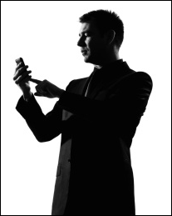

**Report**

**Filtered  
Notification**

**User Sets Notification Filters**

Some  
Magical Algorithm

**APP**